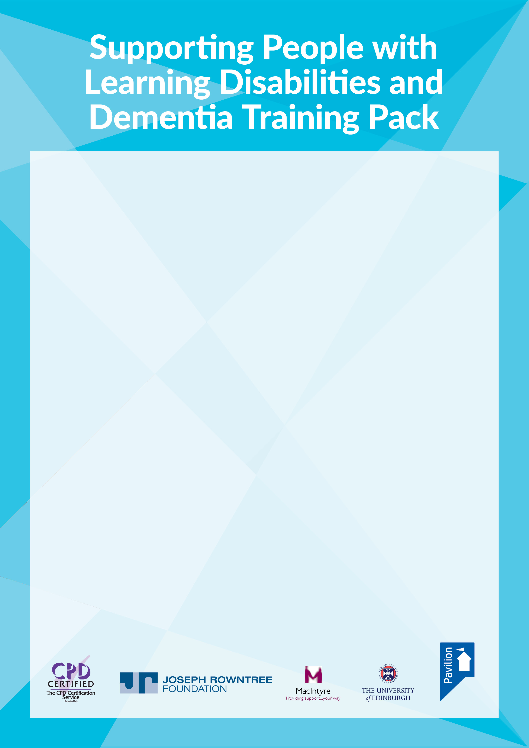

**Certificate of**   
**achievement**

This is to certify that

….…................................................................................................

has attended training on   
**Supporting People with Learning Disabilities and Dementia**   
and covered the following learning outcomes:

1. Understand the potential impact of dementia among people with a learning disability.
2. Understand the impact of the lived environment on people with a learning disability   
   and dementia.
3. Demonstrate awareness of a person-centred approach in the care and support of people with a learning disability affected by dementia.
4. Identify how support can be individualised within an outcome-focused framework.
5. Develop a strategy for talking about dementia with people who have a learning disability.

Signed:………………………………………………………………………………

Date:…………………………………………………………………………………

Title:……………………………………………………………………………….....