Worksheet 3.1:
Preparation – motivation and knowledge

Answering these questions will help you consider what type of intervention might be helpful, and begin to think about content.

1. Why are you considering a sex and relationships intervention for this person?

2. What does the person think about doing this work?

3. What is the person’s current knowledge about sex and relationships?
(Consider formal assessments identified in Chapter Eight: Useful Resources).

4. Which areas is the person keen to learn more about?

5. What might be the impact of this intervention on the person?

6. Are there risks associated with the person’s sexual behaviour, or with undertaking this intervention? If risks are identified, please consider professional input to conduct a risk assessment.

7. Is now a good time to start this work?
Worksheet 3.2a:
A learning contract (example)

Name of client: James Name of educator: Siobhan

What are we working on together? | James wants to talk about not having a girlfriend and how he might get one.
When are we going to meet? | Wednesdays 2pm-3pm
How many times will we meet? | Six times
Where will we meet? | In Oak House, in Siobhan’s office
What happens if I do not want to come or cannot get there? | James or his mum must ring 0122….  You can leave a message or speak to the receptionist who will tell Siobhan.
What are we going to do in the sessions? | - We will talk  - James will talk about how he is feeling  - We may talk about things which have happened in the last week  - James will learn new things about sex and relationships  - Sometimes James might fill in a questionnaire  - Siobhan will help James if he needs it
What are the rules we have agreed? | - James and Siobhan arrive on time  - James tries to talk about how he is feeling  - James does not use his mobile phone in the session  - If James gets upset, he can leave the room. James must try and come back into the room.
These sessions are private between James and Siobhan. This means that no one else will know what we have talked about. | Except:  - James tells Siobhan somebody is harming him, or has in the past  - James tells Siobhan he wants to harm somebody or has harmed somebody  - If James wants to tell his mum some of the things he has talked about  - If James and Siobhan agree to tell somebody about something they have talked about.

Worksheet 3.2b:
A learning contract (template)

Name of client: Name of educator:

What are we working on together?
When are we going to meet?
How many times will we meet?
Where will we meet?
What happens if I do not want to come or cannot get there?
What are we going to do in the sessions?
What are the rules we have agreed?

Worksheet 3.3:
Individual session rules (example)

These are the rules I have agreed with my sex and relationships educator:

I will try to come to every session. I will turn up on time.
If I cannot come or will be late I can call them on ……………………… I will tell my educator if I do not understand something.
I will tell my educator if I need to have a break.

I will tell my educator if I think someone is getting to get hurt or get in trouble.
Worksheet 3.4: Gathering information to help plan a sex and relationships intervention

Every person is different.

Consider what you know about the person’s strengths and difficulties. This may be information supplied through assessment from professionals as well as your own experience and observations. This information will be important when planning a sex and relationships intervention.

General intellectual abilities
If they have been formally assessed, what is the level of their intellectual disability? In general, what are their areas of strength and in which areas do they find learning
more difficult?

Thinking skills

Abstract reasoning
Are there particular sayings or areas that should be avoided, for example, not liking certain words or struggling with certain types of humour?

Stimulus discrimination
What distracts them?
What are the best settings for them to learn in?

Memory
What are their memory skills like?
What is the best way to help them remember things?

Executive functioning
What is their planning like – are there strategies in place to help manage this, e.g. breaking tasks down into smaller parts?

Feeling skills

Emotions
How do they express different emotions?

Sensory issues
Are there sensory sensitivities which they find challenging?

Communication
Types of communication they use (please tick and make notes):

- Verbal
- Written
- Visual
- Pictures
- Object
- Signing (e.g. Makaton/Signalong)
- Gestures
- Other:………………………………
Where are the biggest communication challenges?

How can you adapt your communication to help the person understand you and the work? Can/do they use any technology to support their learning?

Concentration
How long can they focus for?

Based on this, how long do you think your sessions should last?
Worksheet 4.1: Keeping safe and private

What is private?

What you say in your sex and relationships sessions is private.


That means that the person helping you will not talk to other people about what you say.

Sometimes the people helping you have a supervisor.

They talk to their supervisor about their work so they can help them do a good job. The supervisor will not talk to other people about what your helper has said.
Your helper will take notes about the sessions and keep these safe.

When would your educator talk to others?

If the person helping you is worried about you being hurt or hurting someone else they will have to tell other people.

Your helper will talk to you about this first. This is called safeguarding.

Safeguarding means making sure you are safe from abuse and neglect. It can help you to be independent and make choices
Abuse is when someone hurts you or treats you badly. Abuse is always wrong.

Different types of abuse

There are different types of abuse:

Physical – when someone hurts you, for example by hitting or kicking you.

Sexual – when someone touches your body or private parts in ways you do not want. Emotional – when people talk to you in unkind ways (e.g. swearing at you, shouting at you). Financial – when someone takes money or things that belong to you.
Neglect – this is when people who are supposed to help you don’t look after you properly.
Worksheet 4.2: My session plan

Name: Educator name:

My sessions will be on …………………………………................... at ………………………………………………..…..

Settling in
What are we talking about today?
Learning about the topic
Quiz – what have I remembered?
Practice – showing what I have learned
Home tasks
End of the session

Worksheet 4.3: Topics check list

Name: Educator name: Date:
Topics that could be covered:

The basics
Topics | ✔ | To be covered in which session?
Ageing and development
Body parts
Functions of body
Menstruation
Wet dreams
Personal care and appearance
Sex terminology
What is sex?
Intercourse and the mechanics of sex
What is masturbation?
How to masturbate
Where it is appropriate to masturbate
Having a family
Reproduction and conception
Birth
How to get help when pregnant
Normalising sex
Sexual positions
How to participate and enjoy sex
What are sexual feelings?
Recognising when sex is painful or not enjoyable
Contraception
Sexually transmitted diseases
Maintaining own physical health
Gender identity
Sexual orientation

Topics | ✔ | To be covered in which session?
Sexual preferences
Unusual sexual arousal and preferences
Unusual arousals (e.g. unusual ways of masturbating)
Explore any sensory issues relating to masturbation
Sensory issues relating to condom use (e.g. ways of dealing with the rubber smell)
Other………………………………………..

Relationships, behaviours, and social interactions
Topics | ✔ | To be covered in which session?
Friends
Dating partners
Boyfriend/girlfriend
Professional
Who you are allowed to have sex with?
Appropriate and inappropriate behaviours in different relationships
Power dynamics in relationships
Interpersonal space
Good and bad touch
Partner consent
Own consent and making informed choices
Good and bad touch
Assertiveness/saying ‘no’
Recognising what sexual abuse is
Where to get help for sexual abuse/exploitation
How to identify and avoid exploitation
Reducing ‘controlling’ behaviours
Appropriate communication with others
Dealing with rejection
Accepting no as an answer
Ending relationships
How to make friends

Topics | ✔ | To be covered in which session?
Conversation skills
How to negotiate more intimate contact with others
Understanding other people’s perspectives
Problem solving in relationships
Interpreting body language and non-verbal communication
Recognising other people’s emotions
Appropriate/inappropriate behaviours in different situations
Public and private spaces
Negative consequences of behaviours
Impact of behaviours on others
Impact of behaviours on self
Sex and the law (legal implications)
Coping skills and managing difficult emotions
(e.g. anger, anxiety)
Recognising own emotions
Managing own impulsive behaviours
Phones and texting
Internet
Social media e.g. Facebook, Instagram, Snapchat, etc.
Other………………………………………..

Worksheet 5.1a: Sex and relationships education – visual timetable (example)

Name: Kiran Educator: Adrian Date: 10th February 2019

Session | Topic | Done  ✔
One |   Body parts
Two |  Relationships
Three | 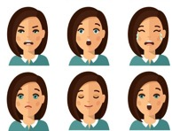 Feelings
Four |  Good and bad touch
Five | Reproduction
Six | Contraception
Seven | Pregnancy

Worksheet 5.1b: Sex and relationships education – visual timetable (template)

Name: Educator: Date:

Session | Topic | Done  ✔

Worksheet 5.2a: ‘Now and next’
communication aid (example)

You may like to cut out and laminate this ‘now and next’ communication aid. Find a selection of pictures relevant to the topic you are teaching, so the person knows what you will be talking about ‘now’ and ‘next’. Once the ‘now’ topic has been discussed, remove the picture, and move the ‘next’ topic to the ‘now’ box. You may like to stick Velcro to the back of the pictures and onto the now and next chart, so they do not fall off.

Name: Jessica
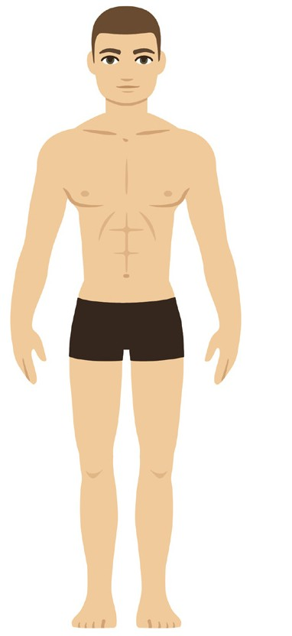

Sex and relationships education

Now | Next
  Body parts |   Relationships

Worksheet 5.2b: ‘Now and next’
communication aid (template)

Name:
Sex and relationships education

Now | Next

Worksheet 5.3a: ‘Circles of intimacy’ (example)

Name: Lilly

These are the most important people in your life.

In different relationships, there are different behaviours.

Strangers: No uninvited touching

People working in the community
(e.g. shop keeper, Police, etc): can talk when need help or when buying something, but no uninvited touching

Teachers and neighbours you know: wave, smile. No uninvited touching

Friends: high-five. Hug for hello and goodbye

Family:
hugs, kiss on cheek

Girlfriend:
sexual behaviour

Me: private
Worksheet 5.3b: ‘Circles of intimacy’ (example)

Name:

These are the most important people in your life.

In different relationships, there are different behaviours.
Worksheet 5.4a: Social Story™ (example)

When making a Social Story™ you may want to put a picture and sentence per page.

When reading through the story, go through one page at a time. You may want to break this down over time, rather than going through the whole story in one go.

Point to the picture as you read each page.

To check the person’s understanding, you can ask them to tell you what is in the picture, who’s who, and what is happening. You may then want to ask more specific questions, about how the characters feel, what they are doing, and so forth. For more resources on how to develop Social Stories™ see Chapter Eight.

This Social Story™ was written for a fictional person called ‘Millie’ who lives in a residential home, who often walked around her shared residential home naked. As she did not understand the rules about where she could be naked, this Social Story™ was written with her, and her care staff read through it with her to remind her of the social rules about being naked.

1 2

Millie’s Social Story

Where is it ok for me to be naked?

3 4

I can be naked in private places.
I can be naked in my bedroom
when I am on my own.

5 6

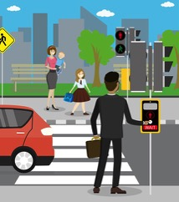

I can be naked in the bathroom

when I have a shower or a bath.

7
I cannot be naked in public places
where there are other people.

8



I cannot be naked in public rooms,



such as the lounge or kitchen.

I must wear clothes in public places.

Worksheet 5.4b: Developing a Social Story™

Questions to consider and answer before developing a Social Story™ for someone.

Topic:
What is the story about? What social situation is it regarding?
Specific information for the social situation in the story:
Where does the situation occur?
What is it about? What happens in the situation?
Who does the story concern? Who does the social situation occur with?
When does the situation occur?
How often does the situation occur?
Why is the story needed?
Who is the best person to write this story?
How often should the story be shared or read with the person?
Who will the story be shared with?

Worksheet 6.1a: Session summary sheet



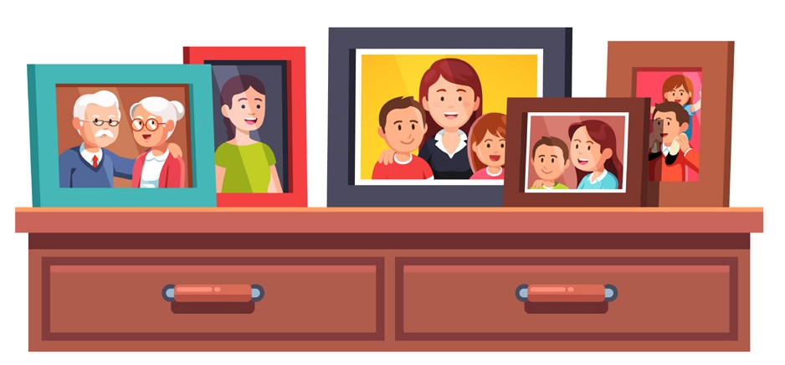



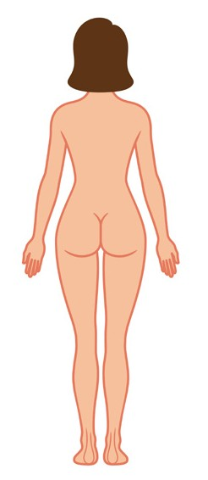



(example)

Summary of Linda’s session

Today we talked about: public and private spaces

Public | Private
 | 
Important things to remember: Public places | Important things to remember: Private places
- Where anyone can go  - llots of people I do not know | - where only you and your family can go  - people you do not know should not be in your private place, unless you have invited them.
In public places you can: | In private places you can:
Keep your clothes on  Do not touch yourself | Undress  Touch yourself



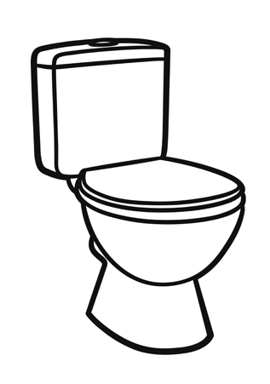

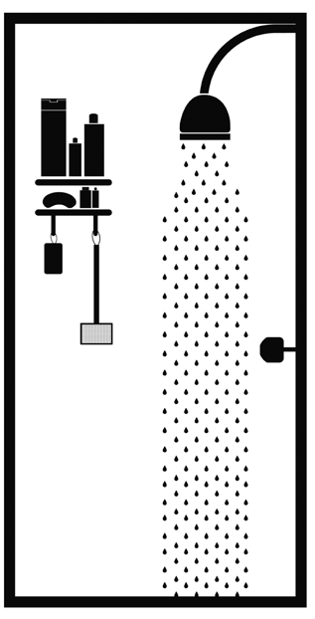

Examples of public places | Examples of private places
School    Outside  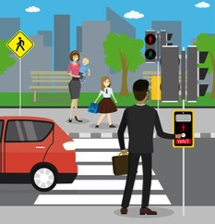  Shops | Bedroom    Bathroom

Worksheet 6.1b: Session summary sheet
(template)

Summary of session

Date:

Today we talked about:

Important things to remember
Worksheet 6.2: Person’s system and involvement

Who will help me and how?

Name: Date:

I would like other people to help me (point or circle):

Yes 

No 

Who I would like to help me?

e.g. family members, carers

What will they do to help me?

e.g. remind me of what I have learnt outside of my sessions, join my sessions, look at my summary sheets with me, speak to parents or carers without me there
Worksheet 6.3: Anticipate, practice and review (template)

Here, a specific event might be coming up which may present some challenges for the person. The educator and the person can agree what might be challenging, generate a plan of action, practice how that might go, and then review after the event. If necessary this process can be repeated to take the issue onto the next step, or if the first plan did not work.

What is the event?

What might go well?

What might be difficult or go wrong?

What do we want to happen?

How can we make this happen?

How can we practise before the event?

How will we know it went well?

When will we talk about how it went?
Worksheet 6.4: Analysis and experimentation

You might use this as a guide when you want to help a person to review and understand a particular event that has already happened. This might be particularly helpful for repeated behaviours that are inappropriate or not going so well.

Did anything go well?

What did not go well?

How do we know it is a problem?
e.g. other people are upset, someone got into trouble

What else could we try?

For each idea think about the good things you could try and any problems.
Good things:

Problems:

Pick the best things you could try:

How can we try this out?

When will we talk about how it went?

