Handout 3.1: Setting up the health screening desensitisation clinic
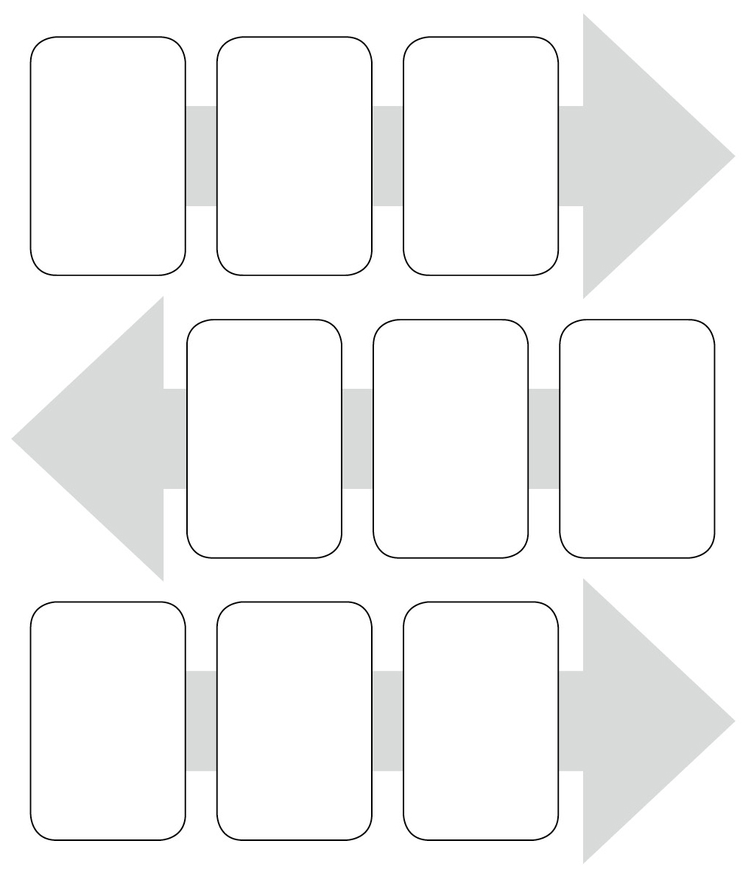

1
Meet with GPs,
practice nurse, practice manager, service provider and get them
on board.
2
From referrals
received implement screening process.
3
Meet each
individual and their carer
and complete barriers checklist.

6
Complete
person-centred desensitisation profile with each individual and their carer, ensuring barriers
and reasonable adjustments are
addressed.
5
Ensure service
providers and carers ‘sign up’ and complete commitment tool.
4
Implement staff/
carer training.

7
Prepare the
environment. Equipment. Monitoring forms.
8
Commence
desensitisation sessions ensuring
‘homework’ is given to the individual and carer.
9
Evaluate progress
weekly and ‘tweak’ profiles to maintain person-centred approach.

general

Having screening equipment available at each appointment/session is an important part of environment preparation and is advisable to enable flexibility and person-led appointments.

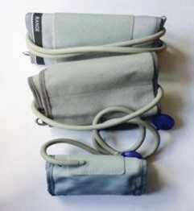
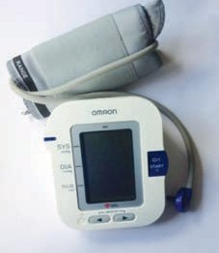
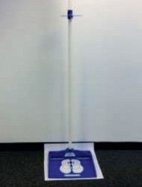
Electronic and manual BP machines Different sizes of cuff

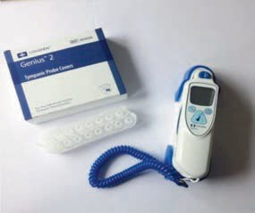
Tympanic thermometer and ear cuffs Height measure

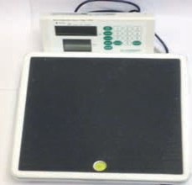
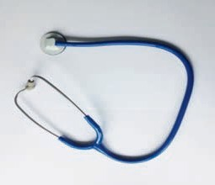
Stethoscope Scales with BMI indicator

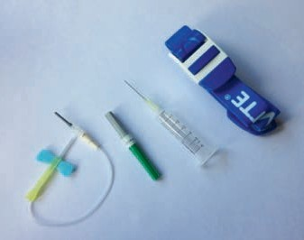
Tourniquets, needles and syringe, including butterfly needles which are useful for some individuals as the actual needle is smaller and they feel more comfortable with this visually.

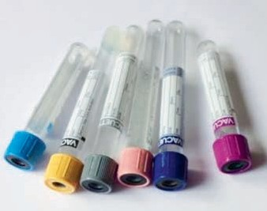
Blood tubes

Useful for some individuals who require very specific desensitisation. If a different colour tube is used when having a blood test this can cause some people with autism spectrum disorder to become very anxious and distressed.

Disposable Tourniquets

These can be useful regarding infection control and also for individuals to use when ‘practising’ at home in between sessions.

general contd.

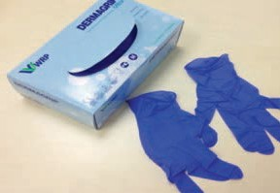

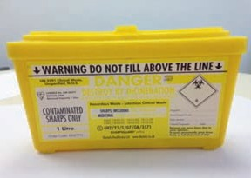
Gloves Sharps box

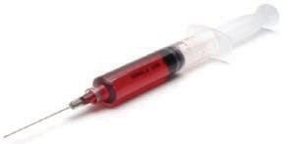
Fake blood

For some people fake blood can be useful to help desensitise them to the sight of blood. If a ‘practice’ syringe is filled with fake blood this enables an individual to visually desensitise to this as part of the process.

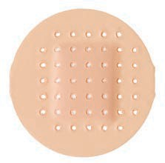

Plasters Cotton wool

For one-to-one ECG desensitisation it can often be enough to familiarise the individual to having the electrodes placed on their body and attaching the leads. This can be implemented in conjunction with joint working with an ECG practice nurse at the individual’s surgery, to desensitise to the actual ECG machine.

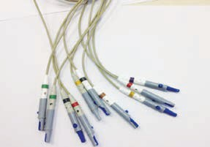
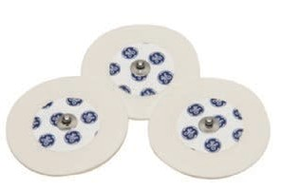
Electrodes ECG leads

If running ECG desensitisation clinics it may be advisable to have a portable ECG machine. This enables the individual to be familiar with the whole process. As part of the pilot project we were kindly donated an old ECG machine which we used. This reduced the concern when familiarising people who may become challenging towards expensive surgery equipment.

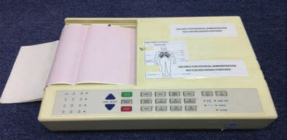

In South West Kent the community learning disability nurses (CLDNs) identified the need for increased health screening for people with a learning disability.

As learning disability link nurses with GP practices, part of our role is to ensure appropriate facilitation of generic health services and the application of reasonable adjustments to enable this, in turn minimising the morbidity and mortality of the learning disability population. This supports meeting the requirement of the Learning Disability Enhanced Services (LDES).

Establishing the need for the project
The CLDNs identified the need for a desensitisation group and decided to pilot it in a large residential service in South West Kent. We met with the GP and practice manager of the surgery that covers the service identified to establish the need for the group and to achieve collaborative working. We then met with the residential manager of the service to discuss the pilot group and to get them on board.

Screening process
We implemented screening for the group. The GP identified individuals as having medical needs and requiring health screening and further investigation. We met with the individuals and their keyworkers within their own homes, identifying needs and experiences. Mental capacity, best interest issues and risk assessments were assessed at this point. All individuals involved had been highlighted as having difficulties accessing health screening.

Aims of the pilot group
 To enable the 10 people with a learning disability to successfully access health screening by their GP/practice nurse as part of the DES.
 To raise awareness of preventative measures, whilst ensuring optimum health and well-being is maintained.
 To ensure previous unmet health needs are met.

Outcomes for the group
 To reduce anxieties associated with attending GP/health screening appointments.
 Individuals attending the group to successfully access health screening.

Implementation of the group
The original plan was for 12 weekly sessions to be implemented with 10 identified individuals, six sessions on the residential site initially, with a view to transferring

the remaining six sessions to the GP surgery. However in response to individual need and the intensity of desensitisation required for certain individuals, we provided 12 sessions on the residential site and 12 sessions at the surgery.

We purchased all the necessary health screening equipment prior to the group commencing: BP machines, tympanic thermometer, scales, height measure, syringes and needles, tourniquets and stethoscope, gloves, alcohol wipes.

Staff training was undertaken prior to the group commencing, targeting keyworkers for each individual and the manager of each house, to ensure staff commitment and understanding of the process. A session at week six reflected on progress and challenges faced.

We identified an appropriate room on site for the sessions to take place each week. For individuals who had extremely high anxiety levels and were not able to access the room, we visited them in their own homes initially.

Sessions ran for 2.5 hours. People were either seen individually or in groups of maximum two people. This enabled us to be flexible with time slots for each individual across the 2.5 hours.

The first session was used to complete a desensitisation profile with each individual. The desensitisation profile was used to highlight the overall aim for each individual, e.g. to attend a GP appointment to have blood pressure taken. The profile then clearly stated how this was going to happen, breaking it down into achievable steps, detailing when each step would be implemented and who would be responsible for ensuring it happened. Each profile was individualised.

Objectives were set with each individual and the staff supporting them. Monitoring charts were given to complete weekly, to record achievements and difficulties faced so that we could review at each session. This enabled us to evidence successes and concerns.

Each ‘desensitisation profile pack’ contained:

 a desensitisation profile
 an ‘example’ desensitisation profile
 ‘my health measurements’ sheet to record any measurements successfully taken at the sessions
 a treatment log sheet to record equipment used e.g. blood pressure cuff and how the individual responded
 a desensitisation monitoring chart to record interventions implemented with the individual in between sessions e.g. familiarisation with the environment, familiarisation with the equipment, sensory work, social stories etc.

Examples of interventions used include:

 Desensitisation to touch and pressure on the arm to prepare for BP screening.
 Familiarisation with all equipment.
 Specific issues with procedures, such as blood tests.
 Desensitisation to sensory stimuli such as the noise of the Velcro on the blood pressure cuff, the beeping noise of the tympanic thermometer, the pressure of the BP cuff, the smell of alcohol wipes etc.
 Building a rapport with the nurses and familiarisation with the room or GP
surgery to enable the individual to be able to enter the building.
 Using health screening stories daily to enable the individual to become familiar with the process of attending the surgery and the identified screening.

Each individual was involved throughout the process ensuring a flexible, person- centred approach was implemented whilst maintaining their dignity, respect and individual rights.

Positive progress was made over the period of 12 weeks. All individuals successfully transferred from the sessions held on the residential site to the clinics held at the GP practice, attending weekly/fortnightly.

Due to the positive response to the clinics and ongoing need of the individuals, the desensitisation clinics were continued once the pilot group had been completed. This enabled individuals that had attended the pilot group to carry on with familiarisation. It also enabled the clinics to be opened out to other individuals who had been referred to the team for desensitisation work re: health screening.

Four individuals from the pilot group were identified as requiring more intense desensitisation around blood tests. CLDNs provided intervention in between the clinics, providing the individuals and their carers with step-by-step guidelines to achieve a blood test.

One individual from the group was highlighted as needing an ECG. In response to this a specific ECG desensitisation programme was compiled and implemented with him, in addition to the ongoing screening work.

The essential key factors highlighted throughout implementation of the pilot group included the screening process, preparation of the environment, individualised programmes, allowing time, flexibility of approach, going at the individual’s pace not the clinician’s agenda and the ability to remain focused and determined.

There were many positive outcomes from the pilot group which are discussed in the next section along with challenges faced.

Positive outcomes
Positive outcomes from the pilot group include:

 All individuals accessing the pilot group made positive progress.
 All the individuals successfully attended the GP practice and have achieved blood pressure and temperature monitoring and have been familiarised with other health screening equipment such as tourniquets, stethoscopes, gloves, alcohol wipes, blood glucose (BM) machine, scales and height measure.
 The CLDNs have routinely successfully recorded health screening observations with all the individuals and shared this information with the GP, informing subsequent treatment and referrals.
 Following the pilot group, these individuals have been able to access the GP/practice nurse with their carers without the CLDNs being involved. This highlights success with fading out once the individual has reached the identified stage.
 Out of the 10 individuals, five required blood tests. Four out of the five have successfully had blood tests following the desensitisation work. The fifth individual was very close to having his blood test. He had had two initial attempts and then unfortunately moved to another area.
 Two individuals successfully had ECGs at their GP practice.
 There have been positive responses to the desensitisation work both from people with a learning disability, the service provider and the GPs at the practice.
 There has been an improved working relationship between the service provider, GP surgery and the nursing team.
 Increased referrals to the nursing team have been received for health screening desensitisation/familiarisation from the service provider, other service providers and GPs.
 Trust and familiarisation has improved between the individuals themselves, the service provider, the nursing team and the GP practice.

Challenges faced
 Time constraints were a challenge. Preparation, implementation and evaluation for the pilot group each week was time consuming on top of other professional commitments.
 Changes of venue for the group at the residential service occurred on several occasions. For certain individuals this set them back due to their extremely high anxieties about accessing unfamiliar rooms, making the process longer for them.

 A small percentage of the staff supporting the individuals had a negative attitude towards the work. This had a significant effect on the individuals they were supporting. In one case following a very positive six weeks, an individual needed to go back to the beginning stages of desensitisation following inappropriate comments from a member of staff.
 High staff turnover in certain houses meant that original staff involved in the training left the service and other staff may not have the same commitment or understanding of the process.
 Weekly objectives were not always implemented affecting the progress for that individual. Additional time was required to meet with managers of the service in addition to the staff training sessions, to ensure the desensitisation profiles were seen as part of the daily routine for each individual.

Overall the positive outcomes far outweighed the challenges faced. The aims and objectives for the group were achieved.

As a child Robert had repeated ear infections which caused him significant pain resulting in self injury. He has autism and does not like being touched. He had very stressful and frightening experiences at the hospital when attending ENT appointments regarding grommets being fitted.

These experiences included not knowing what was going to happen and why, unfamiliar environments, people and equipment, being touched by others when he did not want to be, having to wait for long periods of time in the waiting room, and not being in control of any of the procedures. Robert was held down physically for all invasive procedures as a child.

As a result he associates hospitals with pain and distressing experiences.

Kim was nine years old with severe learning disabilities, autism and challenging needs.

Kim was very anxious regarding entering any new buildings, particularly medical buildings. Her parents had tried to support Kim to access the dentist but due to her anxieties and subsequent challenging behaviour they were unsuccessful and all attempts stopped. As a result Kim did not have any dental check-ups or treatment for several years.

Following a period of significant challenging behaviour including biting herself and biting others it was established that Kim required urgent input from dental services. Due to her high anxiety levels regarding any medical interventions it was agreed that she should have her dental examination under general anaesthetic at the hospital.

Kim became very distressed entering the hospital. Kim was administered a sedative which had the opposite effect and her anxieties were heightened and her behaviour further deteriorated. This resulted in physical intervention from parents and medical staff to enable anaesthetic to be administered.

Kim required removal of several teeth whilst under anaesthetic and experienced pain following the procedure.

As a result this experience has negatively influenced Kim when she has required further medical interventions, in particular hospital appointments.

During the screening for the desensitisation pilot project, information from Thomas’
father included:

‘There is no way you will get him to have any health screening or a blood test. He goes ape and right from a small child has had to be pinned down to do anything.’

The house manager of Thomas’ service confirmed that his anxieties and subsequent behaviour when attempting any medical appointments had resulted in failed appointments. The GP had started to visit him at home, however had had no success in any health screening or health checks.

This clearly highlighted why Thomas experienced such high anxiety levels with medical appointments and his subsequent refusal to attend any medical appointments once he became an adult.

Nigel was 15 years old, had moderate learning disabilities with severe challenging behaviour at times. Due to high anxiety levels associated with health appointments, Nigel would refuse to get into the car if he knew he had a medical appointment.

Consequently staff supporting Nigel told him they were going to the seaside for the day, when in fact he was going to the hospital for dental treatment. Needless to say this caused him considerable distress and he stopped trusting people who cared for him. This resulted in him refusing to go out anywhere in the car as he was never really sure where he would be going and what would happen to him. This overall situation deteriorated, resulting in a referral to the community learning disability team (CLDT) when Thomas became an adult. The staff felt he may have agoraphobia.

Handout 3.8: Supporting an individual through the desensitisation process

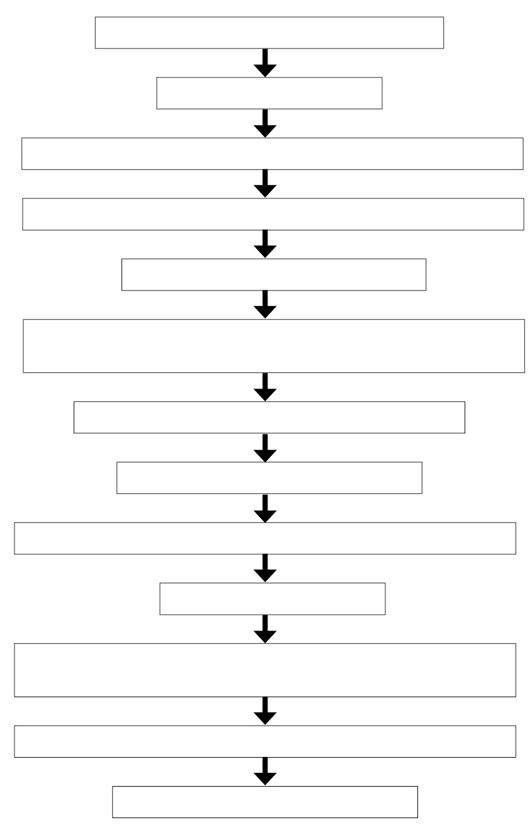

Screening process

Assess capacity

Complete barriers to health screening checklist

Identify reasonable adjustments required

Person-centred/creative techniques

Commitment tool to be completed with medical/health professionals, carers and families

Complete desensitisation profile

Health facilitation stories

Identify specific desensitisation programmes

Prepare environment

Implement desensitisation – incorporate into weekly schedule and carry out homework

Complete recording and monitoring charts

Feedback to GP/practice nurse

