A4: Referral form

Confidential NVR programme referral form

Referred child/ren:
Date of birth:
Address:

Name(s) of parents/carers:
Phone number:
Ethnicity:

Name of referrer:
Date of referral:
School/training of child:
At what tier is this case currently held? (if applicable)
Are you able to attach a recent assessment?
Please draw a genogram/family tree (see below for guidance):

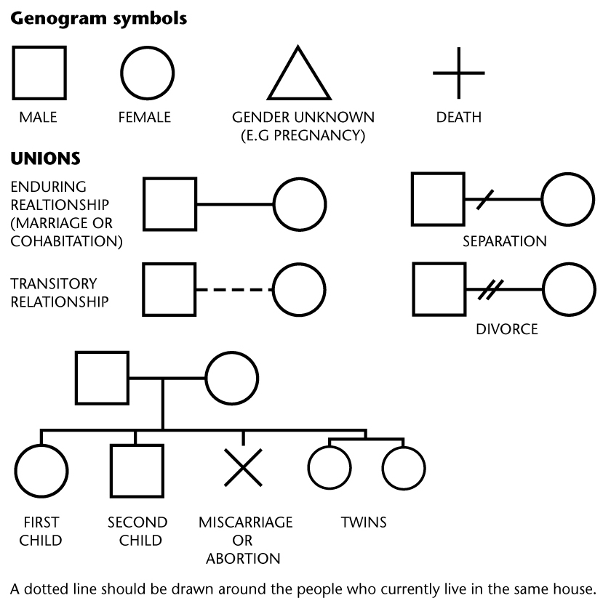

Why do you think that this family would benefit from NVR at this point in time?

From the conversations you have had with the family about this referral, what would you say is their understanding of the approach and their commitment to NVR?

What do you think the family’s hopes for change would be from attending these sessions?

What would be your expectations of the outcome of these sessions?

What strengths do the family show that would enable them to make use of this approach?

What is your current role with the family and how will this referral change your role?

Any other information:

We agree to this referral for NVR

Signed:
Family’s name (printed):
Date:

Name of referrer:
Locality:

For NVR team use:
Top of Form
Date discussed: Discussion recorded Y/N
Bottom of Form
Accepted for NVR Not accepted Further info required Referrer informed .

