Session 3: The baskets

H16: Baskets

Identify up to two of the highest priority behaviours/things to go in the smallest basket for each family.

Behaviours that you will choose not to respond to:

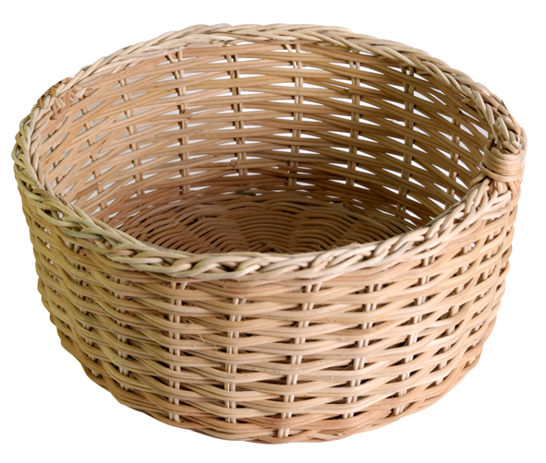

Behaviours that you are prepared to negotiate about:

Behaviours that you are going to focus on and prioritise:

